Constant Acceleration - Questions
June 2017 Mathematics Advanced Paper 1: Mechanics 1

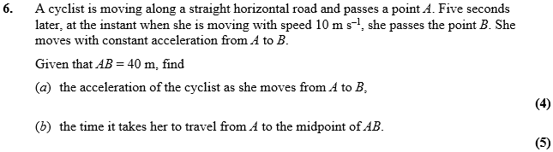

June 2015 Mathematics Advanced Paper 1: Mechanics 1

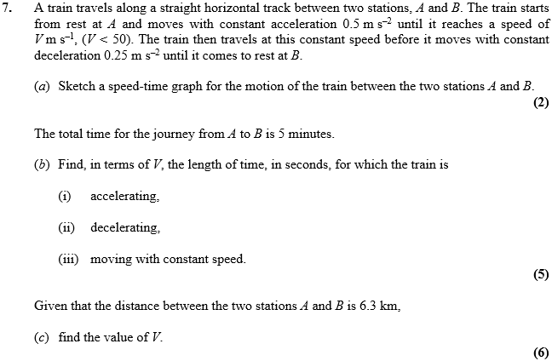

May 2013 Mathematics Advanced Paper 1: Mechanics 1

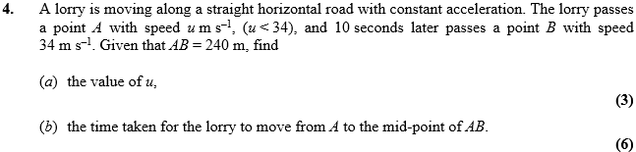

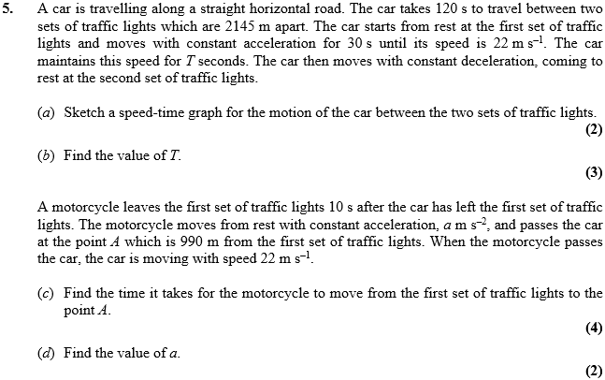

May 2012 Mathematics Advanced Paper 1: Mechanics 1

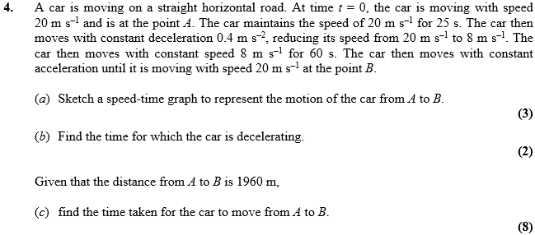

Jan 2010 Mathematics Advanced Paper 1: Mechanics 1

